OUTPUT:

Q1:

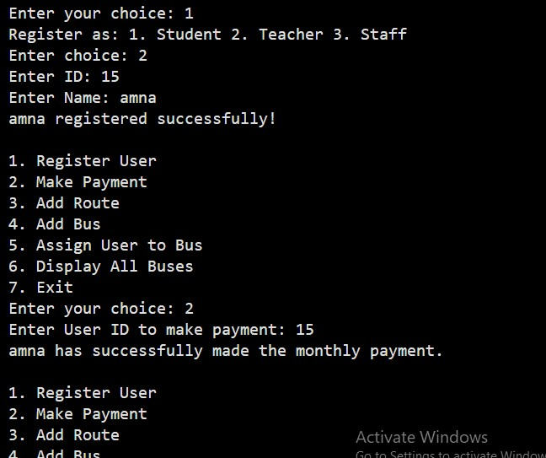

Q4:

